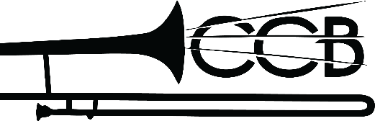
Clovis Community Band
Norvil Howell Scholarship Application

Thank you for applying for the Clovis Community Band Scholarship. This scholarship is for students who live within 50 miles of Clovis, NM and have been in a band or choir throughout High School. You do not have to be a music major in college to apply. We do require that you be enrolled as a college student beginning in the fall semester.

Date: _____________________

Name: ______________________________________________________________________________
Phone Number: ________________ Email: _______________________________________
College to AttendL ___________________________________________________________________
Prior High School: ___________________________________________________________________

Total award: $500

Please submit an essay that is no less than 250 words answering the following statement:
• Describe in thorough detail 3 skills you acquired in your experience as a musician and how you might expect those skills to help you accmplish your academic goals.

The deadline to submit your application is June 1.

Submit this form and your responses to reighleyln@gmail.com.

Thank you for applying!

